The purpose of this tutorial is to demonstrate how to provide access to sensitive medical record information to your patients over the web.

The first step is to export and save the patient’s medical record out of Crystal. To do this, you will navigate to **Records** > **select patient name**.   
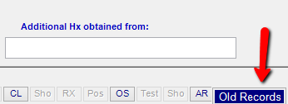   
Select the ‘old records’ button to access a previous medical record.

Next, select **EHR** > **Print to PDF** (which is the last option in the list)

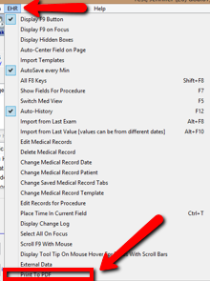  
  
In the printer dialogue box, check the option to print to file and click OK.  
  
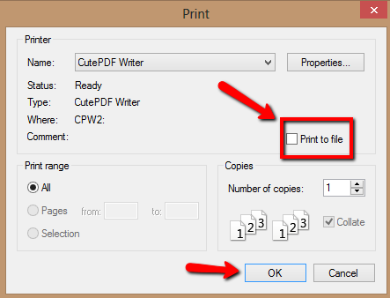

Next, you will be prompted where to save the document. For the purpose of this tutorial, I have saved the medical record to my desktop. You also have the option at this point to name the medical record file; if not the default title will be ‘medrec’. Click **save** and the item will print to a file on your desktop.

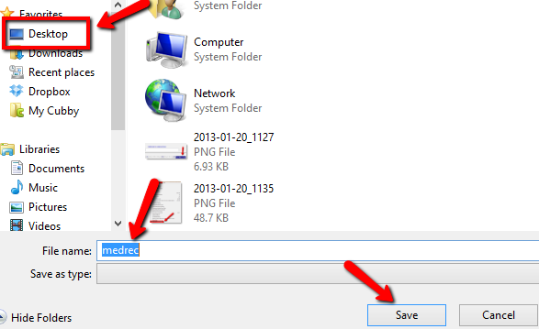   
  
Minimize the programs you are in to verify that the medical record is available on your desktop: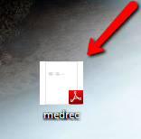  
  
In Crystal, navigate to the patient’s file and select the **Files** tab.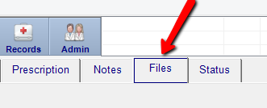  
  
Select the button titled **Online Documents:** 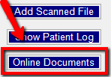

The green online files box will appear. Set a username and password and click **Add File**. Note: The username and password are not required to be any specific length or type of characters. It is personal preference.  
  
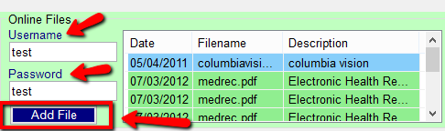  
  
On this screen, select the **Find** option.

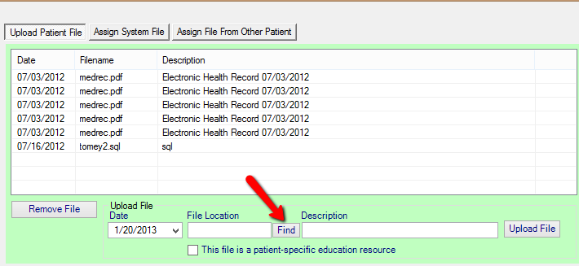  
  
In the file selection window navigate to the location of the file (Desktop > medrec) and click **Open**.  
  
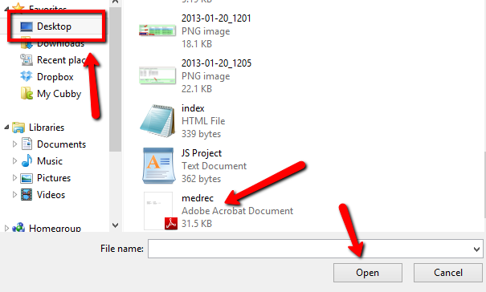

At this point the file is ready to be uploaded.  
  
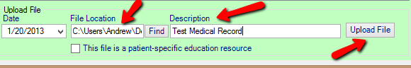  
 Provide a description and click **Upload File**.  
  
The uploaded file will show in the file list:

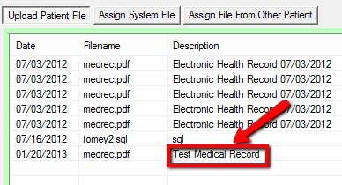  
  
Next, navigate in Crystal to Admin > Website and notice the hyperlink in the box:  
  
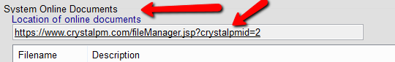  
This is the online location of the patient’s medical record. Click on this link and you will be taken to the following logon screen:  
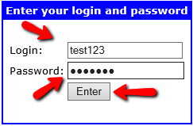  
You will be required to enter the username and password **you assigned** prior to uploading the record (I used test123 and test123). You will also need to provide this information to your patient.   
Click **Enter** once these fields have been filled and you (or your patient) will be directed to the username/password page where there medical record information can be downloaded and viewed.  
